DIS-AM,S-PERU-Moche-400-600 CE-Blow Bottle

**[Moche IV Blow Bottle 400-600AD Weapon Bundle And Wave + Step Motif](http://www.ebay.com/itm/221952944734" \o "opens in new window or tab" \t "_blank)**

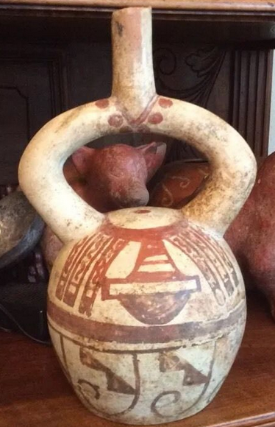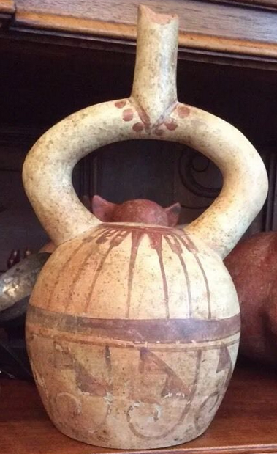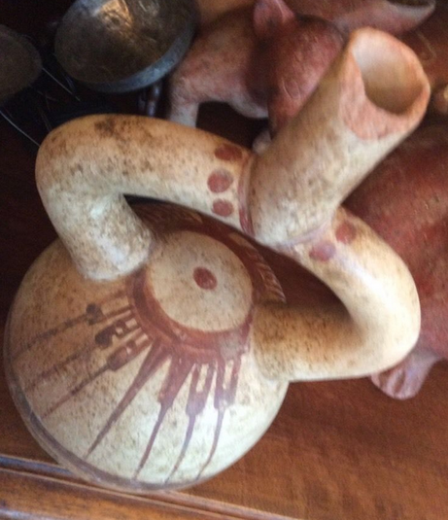

**Order details**

**Sales order**

Sold by [**ancientgas**](http://myworld.ebay.com/ancientgas) ( [992](http://feedback.ebay.com/ws/eBayISAPI.dll?ViewFeedback&userid=ancientgas" \o "opens in new window or tab" \t "_blank) )

**Delivery package 1 of 1**

Estimated delivery **Wednesday, Dec 30, 2015** **- Monday, Jan 4, 2016**

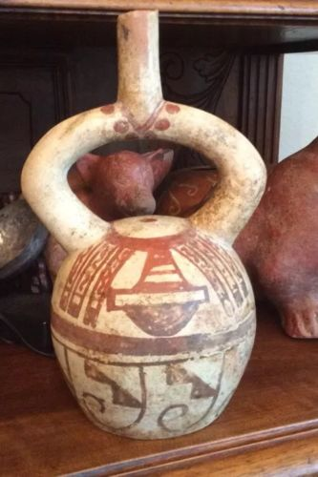

[**Moche IV Blow Bottle 400-600AD Weapon Bundle And Wave + Step Motif**](http://www.ebay.com/itm/221952944734)

|  |  |
| --- | --- |
| Item price | $400.00 |
| Quantity | 1 |
| Item number | 221952944734 |
| Shipping service | USPS Priority Mail Large Flat Rate Box |

**Sales order**

Sold by [**bobski117**](http://myworld.ebay.com/bobski117) ( [2807](http://feedback.ebay.com/ws/eBayISAPI.dll?ViewFeedback&userid=bobski117) )

**Delivery package 1 of 1**

Estimated delivery **Tuesday, Dec 29, 2015** **- Saturday, Jan 2, 2016**

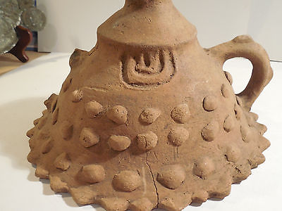

[**Colima Large Incense Lid Shaft Tomb Pre-Columbian Archaic Ancient Artifact Mayan**](http://www.ebay.com/itm/191762068598)

|  |  |
| --- | --- |
| Item price | $34.01 |
| Quantity | 1 |
| Item number | 191762068598 |
| Shipping service | USPS Priority Mail |

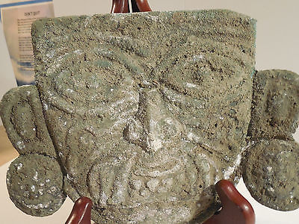

[**Moche Copper Shaman Mask Pre-Columbian Archaic Ancient Artifact Chimu Inca Mayan**](http://www.ebay.com/itm/121843120911)

|  |  |
| --- | --- |
| Item price | $520.00 |
| Quantity | 1 |
| Item number | 121843120911 |
| Shipping service | USPS Priority Mail |